  1. | UNITED INTERNATIONAL UNIVERSITY (UIU)  Dept. of Computer Science & Engineering  Trimester: Summer 2025 (Assignment 1)  ^{Course No: CSE 1115} ^{Course Title: OOP}
1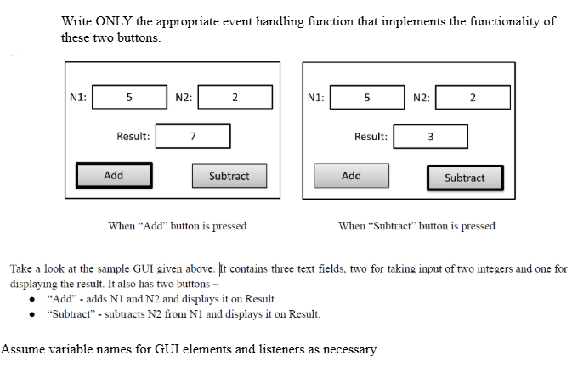
2. Write a Java program to calculate the sum of all elements in an integer array using multiple threads.
Requirements:
- Input:
  - Array size
  - Number of threads
- Generate random integers for the array.
- Divide the array among threads as evenly as possible.
- Each thread computes a partial sum of its assigned range.
- The main thread waits for all threads, then prints the total sum.
Example Output:
Thread-1: elements 0–3 → partial sum = 52
Thread-2: elements 4–6 → partial sum = 34
Thread-3: elements 7–9 → partial sum = 41
Total sum = 127

